Отчёт по лабораторной работе №6. АЛГОРИТМЫ НА ГРАФАХ

Выполнил: Алексей Шимко

Исходный граф:

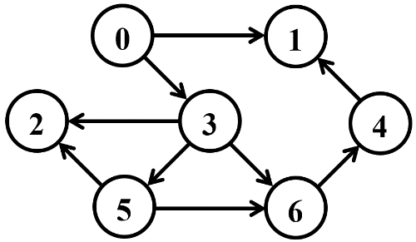

**Задание 1.**

Матрица смежности

|  |  |  |  |  |  |  |  |
| --- | --- | --- | --- | --- | --- | --- | --- |
|  | v0 | v1 | v2 | v3 | v4 | v5 | v6 |
| v0 | 0 | 1 | 0 | 1 | 0 | 0 | 0 |
| v1 | 0 | 0 | 0 | 0 | 0 | 0 | 0 |
| v2 | 0 | 0 | 0 | 0 | 0 | 0 | 0 |
| v3 | 0 | 0 | 1 | 0 | 0 | 1 | 1 |
| v4 | 0 | 1 | 0 | 0 | 0 | 0 | 0 |
| v5 | 0 | 0 | 1 | 0 | 0 | 0 | 1 |
| v6 | 0 | 0 | 0 | 0 | 1 | 0 | 0 |